Claude Code + MariaDB MCP Server — Mini Tutorial

Install Claude Code
In powershell
PS C:\Users\Pacifica> irm https://claude.ai/install.ps1 | iex

PS C:\Users\Pacifica> claude --version
2.1.289 (Claude Code)

PS C:\Users\Pacifica> cd C:\alongkot_299\happy-paws2

PS C:\alongkot_299\happy-paws2> claude

Claude Code
│
│ MCP
▼
MariaDB MCP Server
│
│ SQL
▼
MariaDB
│
▼
happy_paws

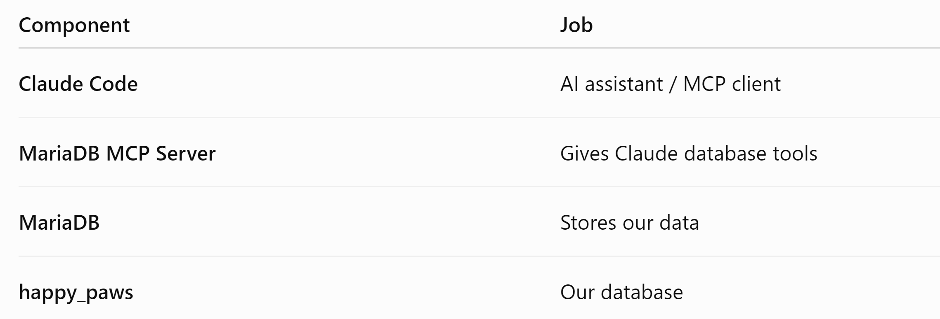

Step 2 of 2 — Understand MCP Client and Server

Setup Install Claude Code
Lesson 1 Understand the Architecture
Step 1 Understand the Connection
Step 2 Understand MCP Client and Server
Lesson 2 Store MariaDB Credentials in Windows
Lesson 3 Install MariaDB MCP Server
Lesson 4 Connect Claude Code to MariaDB MCP
Lesson 5 Query the Happy Paws Database

Claude Code MariaDB MCP Server
│ │
│ MCP request │
├─────────────────────────────────────►│
│ │
│ Execute SQL
│ │
│ MariaDB
│ │
│ MCP result │
◄─────────────────────────────────────┤

Lesson 2 — Store MariaDB Credentials in Windows
Step 1 of 2 — Create Windows User Environment Variables

Setup Install Claude Code ✅

Lesson 1 Understand the Architecture ✅
Step 1 Understand the Connection ✅
Step 2 Understand MCP Client and Server ✅

Lesson 2 Store MariaDB Credentials in Windows
Step 1 Create User Environment Variables ◄── YOU ARE HERE
Step 2 Verify Environment Variables

Lesson 3 Install MariaDB MCP Server

Lesson 4 Connect Claude Code to MariaDB MCP

Lesson 5 Query the Happy Paws Database

We will store MariaDB Credentials as Windows User Environment Variables.

Windows User Environment Variables
│
├── DB_HOST = localhost
├── DB_PORT = 3333 / 3306
├── DB_USER = root
├── DB_PASSWORD = ********
└── DB_NAME = happy_paws

PS C:\alongkot_299\happy-paws2> [Environment]::SetEnvironmentVariable("DB_HOST", "localhost", "User")
PS C:\alongkot_299\happy-paws2> [Environment]::SetEnvironmentVariable("DB_USER", "happyuser", "User")
PS C:\alongkot_299\happy-paws2> [Environment]::SetEnvironmentVariable("DB_PASSWORD", "happypassword", "User")

PS C:\alongkot_299\happy-paws2> [Environment]::SetEnvironmentVariable("DB_NAME", "happy_paws", "User")

Windows User Environment Variables
│
├── DB_USER
└── DB_PASSWORD
│
▼
MariaDB MCP Server

Lesson 2 — Store MariaDB Credentials in Windows
Step 2 of 2 — Verify Environment Variables
Setup Install Claude Code ✅

Lesson 1 Understand the Architecture ✅
Step 1 Understand the Connection ✅
Step 2 Understand MCP Client and Server ✅

Lesson 2 Store MariaDB Credentials in Windows
Step 1 Create User Environment Variables ✅
Step 2 Verify Environment Variables ◄── YOU ARE HERE

Lesson 3 Install MariaDB MCP Server

Lesson 4 Connect Claude Code to MariaDB MCP

Lesson 5 Query the Happy Paws Database

PS C:\Users\Pacifica> echo $env:DB_USER
happyuser
PS C:\Users\Pacifica> echo $env:DB_NAME
happy_paws
PS C:\Users\Pacifica> echo $env:DB_HOST
localhost
PS C:\Users\Pacifica> if ($env:DB_PASSWORD) { "DB_PASSWORD is set" } else { "DB_PASSWORD is NOT set" }
DB_PASSWORD is set

Lesson 4 — Install and Connect MariaDB MCP Server
Step 1 of 3 — Download the Official MariaDB MCP Server

Setup Install Claude Code ✅

Lesson 1 Understand the Architecture ✅
Step 1 Understand the Connection ✅
Step 2 Understand MCP Client and Server ✅

Lesson 2 Store MariaDB Credentials in Windows ✅
Step 1 Create User Environment Variables ✅
Step 2 Verify Environment Variables ✅

Lesson 3 Connect MCP to Our Docker MariaDB ✅
Step 1 Verify MariaDB Docker Container ✅
Step 2 Verify happy_paws Database ✅

Lesson 4 Install and Connect MariaDB MCP Server
Step 1 Download MariaDB MCP Server ◄── YOU ARE HERE
Step 2 Install MCP Server Dependencies
Step 3 Add MariaDB MCP to Claude Code

Lesson 5 Query Happy Paws with Claude Code

C:\alongkot_299
│
├── happy-paws
│ └── Our application
│
└── mariadb-mcp
└── MCP server for Claude

PS C:\alongkot_299> git clone https://github.com/MariaDB/mcp.git mariadb-mcp

PS C:\alongkot_299> cd mariadb-mcp

Lesson 4 — Install and Connect MariaDB MCP Server
Step 2 of 3 — Install MCP Server Dependencies

Setup Install Claude Code ✅

Lesson 1 Understand the Architecture ✅
Lesson 2 Store MariaDB Credentials in Windows ✅
Lesson 3 Connect MCP to Our Docker MariaDB ✅

Lesson 4 Install and Connect MariaDB MCP Server
Step 1 Download MariaDB MCP Server ✅
Step 2 Install MCP Server Dependencies ◄── YOU ARE HERE
Step 3 Add MariaDB MCP to Claude Code

Lesson 5 Query Happy Paws with Claude Code

PS C:\alongkot_299\mariadb-mcp> uv sync

Lesson 4 — Install and Connect MariaDB MCP Server
Step 3 of 3 — Add MariaDB MCP to Claude Code

Setup Install Claude Code ✅

Lesson 1 Understand the Architecture ✅
Lesson 2 Store MariaDB Credentials in Windows ✅
Lesson 3 Connect MCP to Our Docker MariaDB ✅

Lesson 4 Install and Connect MariaDB MCP Server
Step 1 Download MariaDB MCP Server ✅
Step 2 Install MCP Server Dependencies ✅
Step 3 Add MariaDB MCP to Claude Code ◄── YOU ARE HERE

Lesson 5 Query Happy Paws with Claude Code

PS C:\alongkot_299\mariadb-mcp> claude mcp add mariadb --scope user --transport stdio uv -- --directory C:\alongkot_299\mariadb-mcp run server.py

PS C:\alongkot_299\mariadb-mcp> claude mcp list

